INSY7315 — WORK INTEGRATED LEARNING
TASK 1: DOCUMENTATION
Ubuhlebethu ConnectPro
A connected web and mobile system for quotations, invoicing and real-time field-work tracking, prepared for Ubuhlebethu Business Enterprise cc
Team Number | 13
Team Name | Tech Titans
Client Name | Ubuhlebethu Business Enterprise cc
Module | INSY7315 — Work Integrated Learning
Team Members | Musa Janda (St10456109) Group 2, Mhlengi Mndebele (St10384345) Group1, Chuma Makhathini (St10450570) Group 3, Tshudufhadzo Themba(St10461617) group 1, Maphutha Nogana Nkgopjane (St10377354) Group 2, Mmasebotsana Nkosi (St10452632) Group 2


Table of Contents
Table of Contents 2
1. Introduction 4
2. Requirements 4
2.1 Research Conducted 4
2.2 User Roles 4
2.3 User Stories 4
2.4 User Experience Journey Map 4
2.5 Work Breakdown Structure 4
3. Non-Functional Requirements 4
4. Analysis Artifacts 4
4.1 Domain Modelling 4
4.2 Design Artifacts 6
5. Implementation 7
5.1 Sequence Diagram: Login Flow 7
5.2 Sequence Diagram: Quotation Request → Approval 8
5.3 State Diagram: Quotation Lifecycle 9
5.4 Deployment Plan 10
6. Data Schema 10
6.1 Choice of Technology 10
6.2 Entity Relationship Diagram 11
7. Architecture Artifacts 12
7.1 Design Patterns 12
7.2 Architecture Patterns 15
7.3 Cloud Architecture 16
8. Security 17
8.1 Authentication & Access Control 18
8.2 Common Web Vulnerabilities 18
8.3 Data & Infrastructure Security 18
9. DevOps 19
9.1 GitHub Actions Pipeline 19
10. Running Costs 20
10.1 Two-Year Growth Projection 20
11. Change Management 21
11.1 Organizational Adoption 21
11.2 User Adoption 21
11.3 Handover & Transition Plan 21
12. Appendices 22
12.1 Declaration of Authenticity 22
12.2 Prototype Link 22

1. Introduction
This document is prepared for the management of Ubuhlebethu Business Enterprise cc to introduce Ubuhlebethu ConnectPro, a proposed web and mobile system designed to digitize the company's quotation, invoicing and site-progress-tracking processes. Ubuhlebethu is an established, award-winning construction company, operating across Gauteng, Free State, Mpumalanga, Limpopo and Northwest, and currently runs these processes manually — through phone calls, WhatsApp messages, printed documents and department-specific spreadsheets.
The purpose of ConnectPro is to give clients a self-service portal to request and track quotations, give office and QS staff a single system for costing and invoicing, and give field workers and site managers a mobile tool to log work completed and track material usage in real time. This removes the current reliance on phone calls and disconnected paper records and gives management a live view of project status without needing to contact each site individually.
This document sets out the requirements, analysis artifacts, architecture, data design, security approach, DevOps practices, running costs, and change-management plan for the system, and forms the basis on which the team will build and demonstrate the working prototype and, subsequently, the full implementation in Task 2 and Task 3 of this module. ConnectPro is expected to reduce quotation turnaround time from days to hours and eliminate the administrative overhead of manual invoicing

2. Requirements
Requirements were gathered through review of Ubuhlebethu's company profile and services, and through the current-state analysis conducted for the initial project proposal, which identified that the business relies entirely on manual, disconnected processes for client enquiries, quotations, invoicing and site reporting (see Section 2.1 for the underlying research).

2.1 Research Conducted
To better understand the organization, project and end users, the team reviewed Ubuhlebethu's company profile (services offered, project history, and management/ownership structure) and mapped the company's current manual workflow from client enquiry through to on-site progress reporting. This confirmed that no dedicated business system currently exists, that records are kept separately by each department (QS, site managers, corporate affairs), and that field workers have no digital means of logging work completed while on site.

2.2 User Roles
The system identifies six user roles, each with a distinct dashboard and permission set enforced on the back end:
- Client — an external customer of Ubuhlebethu who requests quotations and tracks their own projects, invoices and progress.
- Office / QS Staff — reviews quotation requests (including the AI-generated draft estimate), approves or rejects them, and generates invoices.
- Site Manager — oversees one or more active projects, assigns tasks to field workers, and reviews site reports.
- Field Worker — logs work completed and uploads site photos from the mobile app; has no access to the web back office.
- System Administrator — manages user accounts (view, edit, deactivate, delete) and has visibility of the audit trail; typically an office manager with elevated access.
- Management — senior leadership at Ubuhlebethu (owner, directors) who require high-level dashboards, financial reporting, and project portfolio visibility. Has read-only access to all project data but cannot modify operational records.

2.3 User Stories
User stories are written in the standard format: As a [role], I want to [goal], so that [reason].
- As a Client, I want to request a quotation online, so that I do not have to wait for a site visit before receiving a price indication.
- As a Client, I want to view the status of my quotations and invoices in one place, so that I always know where my project stands.
- As a Client, I want to ask a chatbot about my invoices and quotations in plain language, so that I get answers without phoning the office.
- As Office/QS Staff, I want the system to suggest a draft cost estimate from the project scope, so that I have a faster starting point for costing.
- As Office/QS Staff, I want to approve or reject a quotation and automatically generate an invoice on approval, so that invoicing is faster and less error prone.
- As a Site Manager, I want to see real-time site reports and photos from my field workers, so that I do not have to phone the site for updates.
- As a Site Manager, I want to assign tasks to field workers and monitor their completion status, so that I can ensure all site work is progressing according to schedule.
- As a Field Worker, I want to log completed work and upload a photo from my phone, so that my progress is recorded without paperwork.
- As a Field Worker, I want the app to automatically tag my site photo by construction stage, so that I do not have to manually categorize every entry.
- As a System Administrator, I want to deactivate a user account, so that access can be revoked when someone leaves a project or the company.
- As a System Administrator, I want to view the audit trail of all user actions, so that I can investigate any unauthorized activity or data changes.
- As Management, I want a dashboard of live project statistics, so that I can make decisions without waiting for a phone update.
- As Management, I want to generate executive reports on project performance, so that I can present to the board/ownership.

2.4 User Experience Journey Map
The journey map below shows the primary screens and navigation paths for all six user roles: Client, Office/QS Staff, Site Manager, Field Worker, System Administrator and Management. Each role is shown with its main navigation path and relevant secondary branches, including role-specific actions and end states.
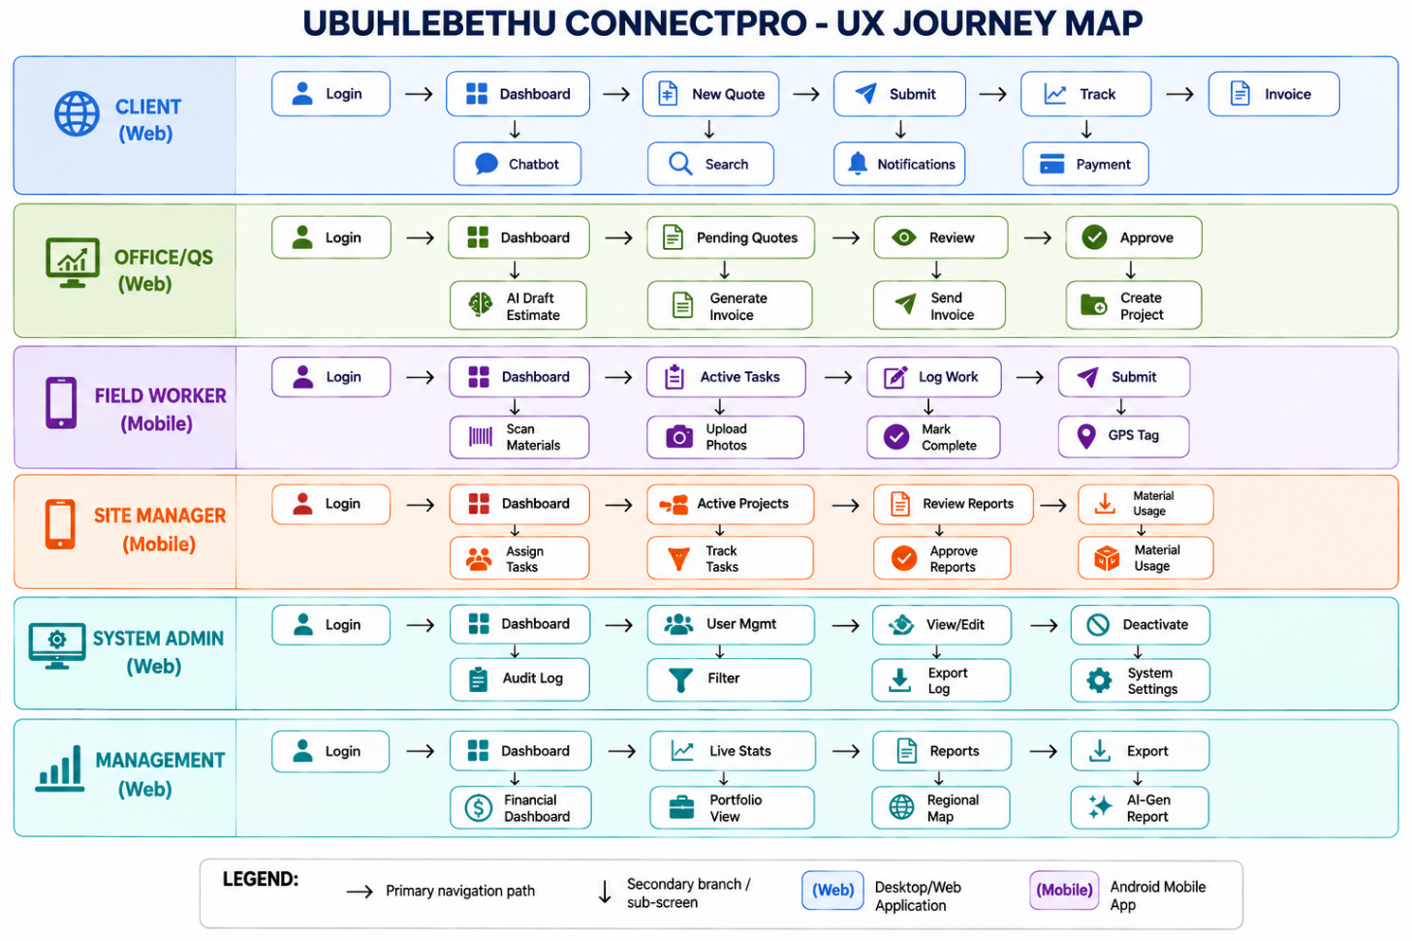
Figure 1 UX Journey Map for the User roles

2.5 Work Breakdown Structure
The table below breaks down the major tasks across the three WIL milestones, showing duration, predecessors, responsible team members and required resources.
Task | Description | Duration | Predecessor(s) | Responsible | Resources
T1 — Requirements gathering | Review client profile, current process, define roles & user stories | 1 week | None | Whole team | Client profile, module manual
T2 — UX journey map & WBS | Map screens per role; build work breakdown structure | 3 days | Requirements gathering | Musa, Mhlengi | Draw.io / Figma
T3 — Domain & design class diagrams | Model core entities and implementation classes | 4 days | Requirements gathering | Chuma, Tshudufhadzo | Lucidchart
T4 — ERD & data schema | Design relational schema and justify technology choice | 3 days | Domain modelling | Nogana | dbdiagram.io
T5 — Architecture & cloud diagrams | Document layered architecture, design patterns, cloud deployment | 4 days | ERD complete | Mmasebotsana | Draw.io
T6 — Security & DevOps sections | Preliminary Documentation for security controls and CI/CD pipeline | 3 days | Architecture diagrams | Mhlengi | GitHub Actions docs
T7 — Running costs & change management | Cost projections and adoption/handover plan | 2 days | Cloud architecture | Tshudufhadzo, Nogana | Hosting provider pricing pages
T8 — Figma / IDE prototype | Build clickable prototype (web + mobile) with dummy data | 1 week | UX journey map | Musa, Tshudufhadzo, Chuma | Android studio & Visual Studio
T9 — Documentation compilation & review | Merge all sections into one document, proofread, format | 3 days | All sections drafted | Musa | Word/Google Docs
T10 — Security documentation | Final Documentation of authentication, access control, web vulnerabilities, mobile security and risk mitigations | 3 days | T6 — Architecture & cloud diagrams | Mhlengi, Chuma | PRSE material, OWASP guidance, Android security documentation
T11 — DevOps / CI-CD documentation | Final Documentation of branching strategy, automated tests, coverage gates, deployment and rollback workflow | 3 days | T6 — Architecture & cloud diagrams | Mhlengi, Chuma | GitHub Actions, xUnit, Coverlet, Docker documentation
T12 — Prototype testing | Validate clickable web/mobile prototype flows against user stories and NFRs | 3 days | T8 — Figma / IDE prototype | Whole team | Figma prototype, test checklist, dummy data

3. Non-Functional Requirements
The following non-functional requirements were identified during a requirements-gathering and validation meeting with Ubuhlebethu management on 05 August 2026 via Microsoft Teams. The discussion focused on the organization’s day-to-day operational needs, expected system usage, user roles, AI functionality, security requirements and anticipated growth. These requirements define the quality, performance and operational constraints that the system must satisfy regardless of its specific functional features.
- NFR-01 — Performance: Web pages and API endpoints must respond within 2 seconds under normal operating load. Core functions such as submitting quotations, viewing projects and recording site reports must remain usable without noticeable delays.
- NFR-02 — Availability: The system should achieve a minimum of 99% uptime during business hours. The application must be hosted by using a managed cloud provider rather than relying on on-premises hardware, reducing the risk of service disruption caused by local infrastructure failures.
- NFR-03 — Security: All data transmitted between users and the system must be encrypted using HTTPS/TLS. User passwords must be securely hashed, and server-side role-based access control (RBAC) must ensure that users can only access functions and information appropriate to their assigned role.
- NFR-04 — Usability: The system must be simple enough for field workers to complete and submit a basic site report in under one minute on an Android mobile device, including the ability to upload a site photograph. The interface should minimize unnecessary steps because field workers may be operating on active construction sites.
- NFR-05 — Scalability: The database and cloud infrastructure must support growth from approximately 100 users to at least 10,000 users without requiring a fundamental redesigning of the system architecture. The solution should therefore allow computing and database resources to be scaled as demand increases.
- NFR-06 — AI Reliability: AI-powered features, including the Quotation Assistant, Chatbot and Natural-Language Search, must not prevent users from completing core business activities when the AI service is unavailable, slow or produces an unreliable response. If an AI request times out or returns a low-confidence result, the system must provide a manual or structured-search fallback within 3 seconds, allowing the user to continue with the task.
- NFR-07 — Compliance: The system must process and store client and employee personal information in accordance with the requirements of the Protection of Personal Information Act (POPIA). Personal information must only be collected, accessed and retained for legitimate business purposes, with appropriate access controls applied.
- NFR-08 — Maintainability: The application must use a layered architecture with clear separation of concerns between the presentation, business logic and data-access layers. This should allow individual features to be modified or extended without requiring large-scale rewrites of unrelated parts of the system.
- NFR-09 — Compatibility: The web application must render and function correctly on the latest two versions of Google Chrome, Microsoft Edge and Safari. The Android mobile application must support Android 10 and later to accommodate the expected devices used by field workers.
- NFR-10 — Localization: The system should initially support English and isiZulu, particularly for field-worker-facing functionality, while being designed so that additional South African official languages can be added as Ubuhlebethu expands its operations across different provinces. Language-specific interface text should therefore be separated from the application's core logic.

4. Analysis Artifacts

4.1 Domain Modelling
The system is built around a base User class (storing core authentication and contact data) that is specialized into six distinct roles—Client, OfficeStaff, Site Manager, FieldWorker, Management, and SystemAdmin—each with role-specific attributes (e.g., creditLimit for Client, canApproveQuotes for OfficeStaff, assignedRegion for SiteManager, skillSet for FieldWorker, canApproveBudget for Management, and isSuperAdmin for SystemAdmin). A Client initiates a Quotation, which captures scope, cost estimates (including AI-generated figures), and an approval workflow (statuses like Draft, Approved, Rejected); upon approval, the system automatically generates both an Invoice (for billing and payment tracking) and a Project (managing budget, timeline, and status). Projects are further supported by SiteReports logged by Field Workers (containing progress updates, photos with AI tags, and location data) and MaterialTasks for tracking work items and materials. Each SiteReport may have one or more Attachments (such as photos or documents) linked to it, while each Invoice can be reconciled against one or more Payment records that track amounts received and payment dates. All users receive Notifications (with priority and read status), while AuditLogs ensure accountability by recording every action.

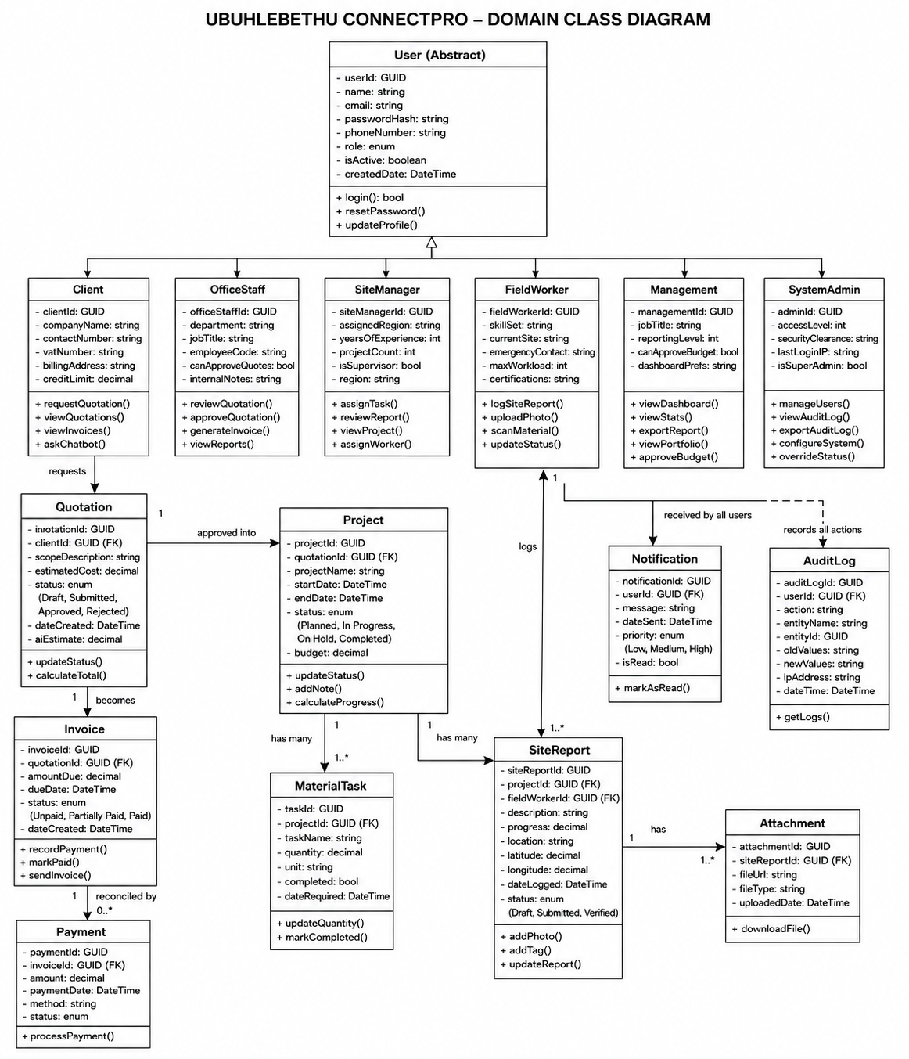
Figure 2 Domain class diagram

4.2 Design Artifacts
The design class diagram below illustrates a representative implementation slice of the system — the quotation workflow — showing access specifiers, key methods and how the Repository pattern is applied. The same structure (Controller → Service → Repository → Entity) is repeated for the other core entities (Invoice, Project, SiteReport).
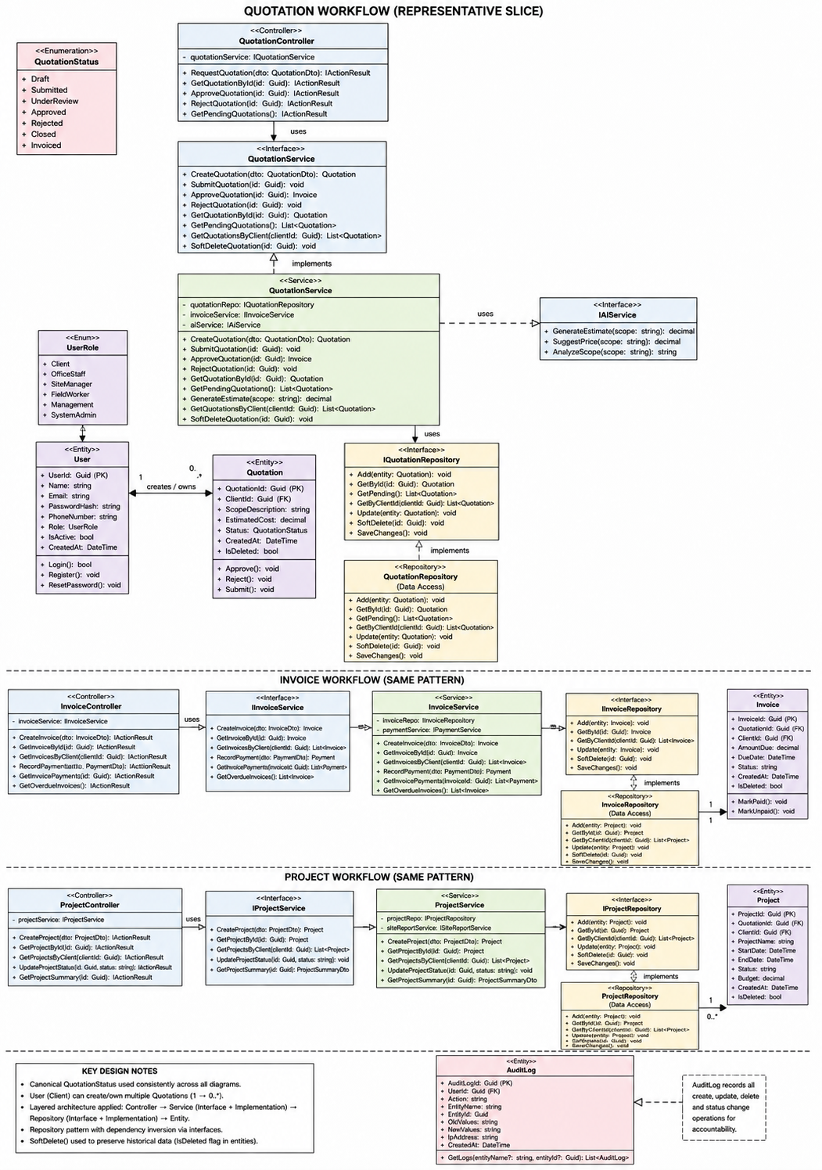
Figure 3 Design class diagram — quotation workflow

5. Implementation
This section documents the two critical flows required by the module manual: the login flow, and one core business flow (the quotation request-to-approval flow). A state diagram for the quotation lifecycle and a deployment plan are also included.

5.1 Sequence Diagram: Login Flow
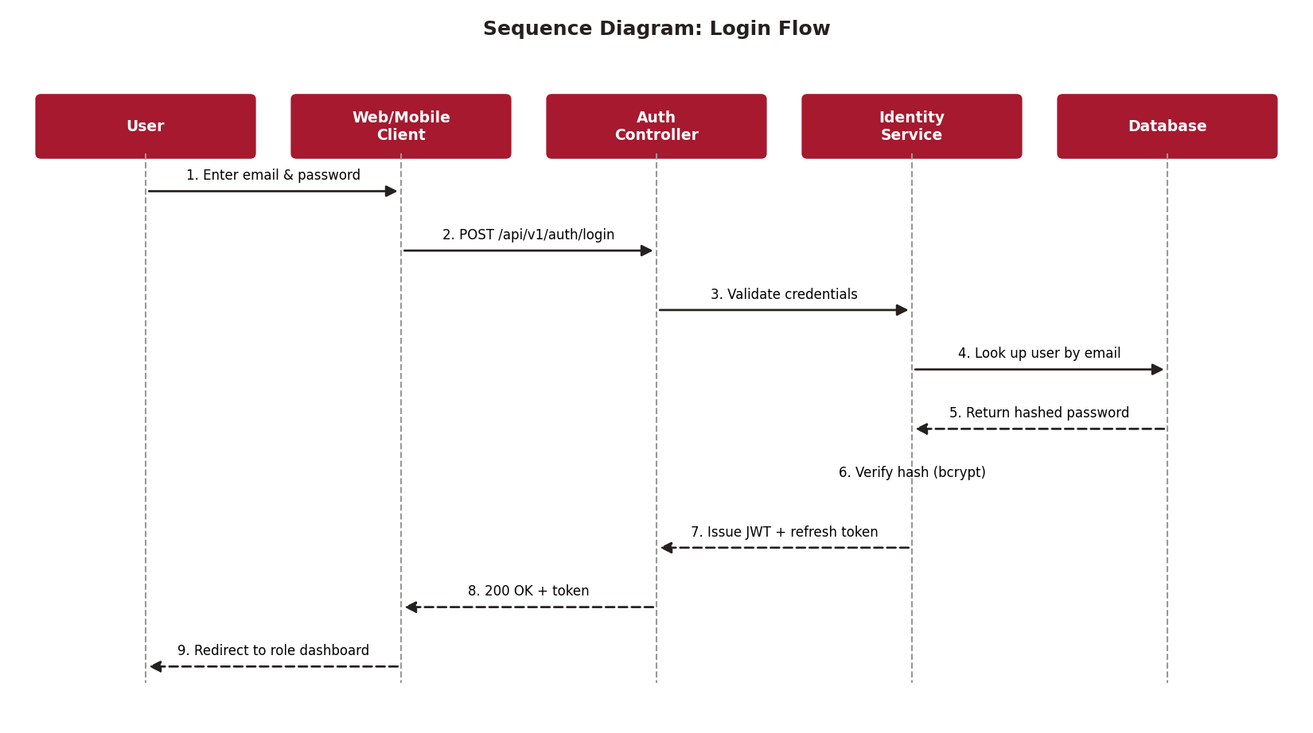
Figure 4 Sequence diagram for the login flow
The client application collects credentials and sends them to the Auth Controller, which delegates verification to the Identity Service. Passwords are never compared in plain text — the stored hash is checked using bcrypt's verify function. On success, a signed JWT and refresh token are issued and the user is redirected to the dashboard matching their role.

5.2 Sequence Diagram: Quotation Request → Approval
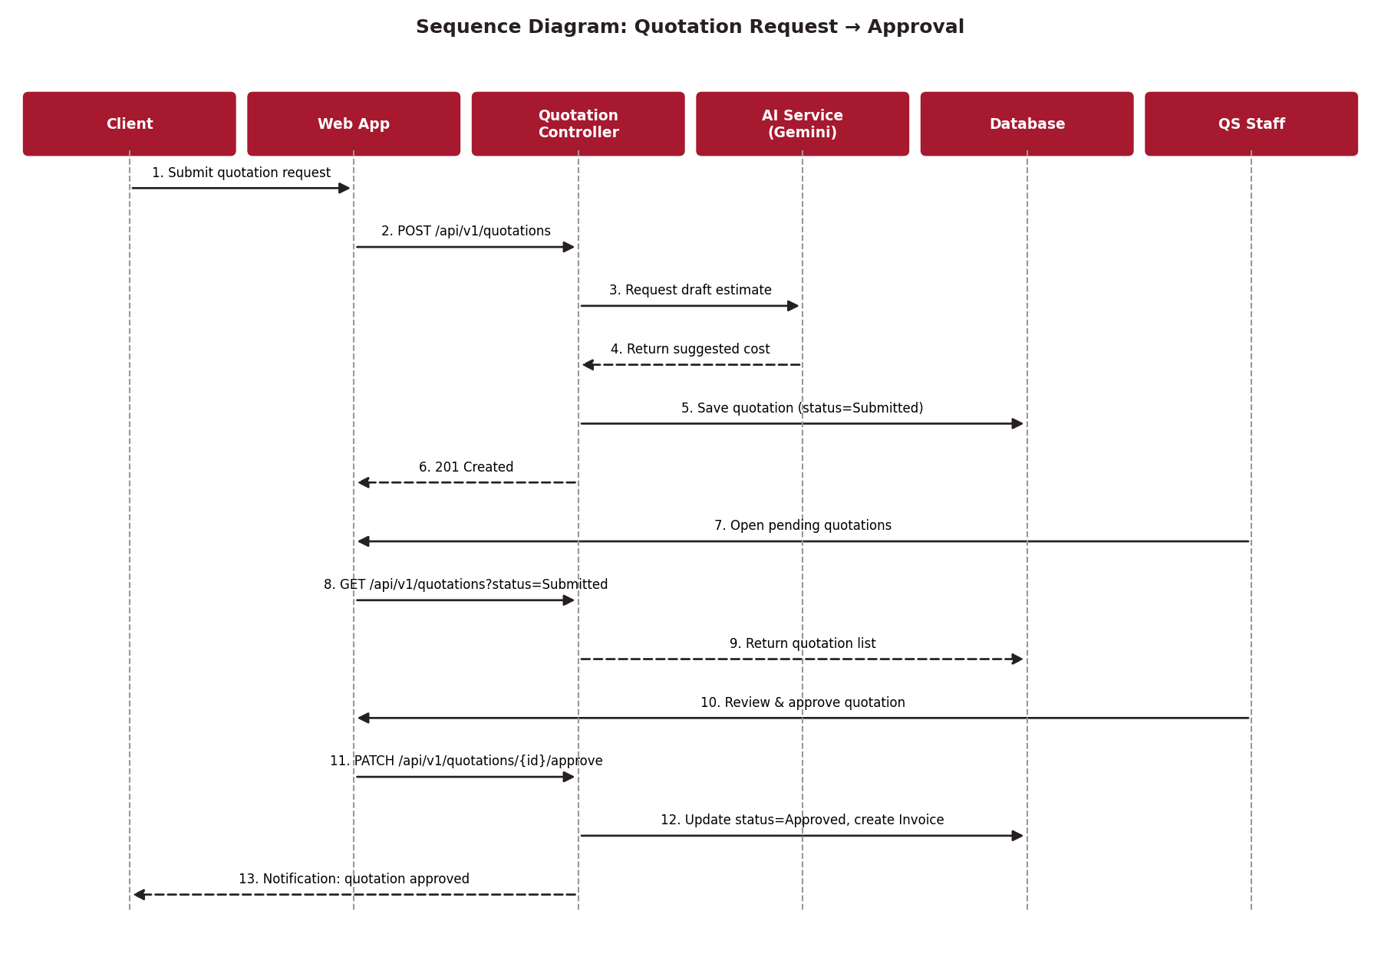
Figure 5 Sequence diagram for the quotation request and approval flow
A client's request first passes through the AI Service to generate a draft cost estimate, which is stored alongside the quotation in a Submitted state — it is never sent to the client automatically. QS staff review pending quotations, and approving one both updates its status and creates a linked Invoice record in the same transaction.

5.3 State Diagram: Quotation Lifecycle
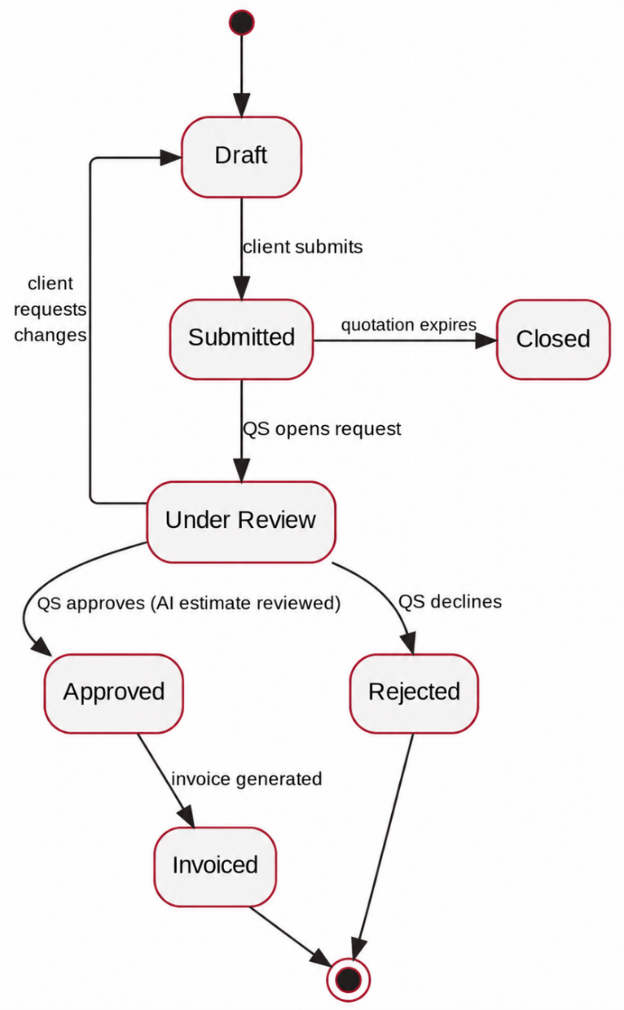
Figure 6 State diagram for a quotation's lifecycle
A quotation begins in the Draft state when created by the AI Assistant or QS staff. From Draft, it moves to Submitted when the QS sends it to the client for review. If the client requests changes, it returns to Draft for revision. Upon client acceptance, it transitions to Approved, which automatically triggers invoice generation. Once invoiced, the quotation moves to Invoiced and is considered complete. From the Submitted state, the quotation may also transition directly to Closed if it expires without client action, or to Rejected if the client declines the proposal. Additionally, if the QS determines that a quotation needs further internal refinement after submission, it can be moved back to Under Review and subsequently returned to Draft for amendments. Terminal states include Closed, Rejected, and Invoiced; no further transitions are permitted from these states. Guard conditions enforce that only allowed state changes occur,for example, a quotation cannot transition directly from Submitted to Invoiced without first passing through Approved.
For formal UML traceability, the permitted transitions are treated as guarded transitions. Examples include: Draft → Submitted [QS sends quotation]; Submitted → Draft [client requests changes]; Submitted → Approved [client accepts quotation]; Submitted → Closed [quotation expires]; Submitted → Rejected [client declines]; and Approved → Invoiced [invoice created successfully]. These guards prevent invalid lifecycle transitions and are enforced by the quotation service.

5.4 Deployment Plan
The system is deployed as three logical nodes: a web/API host running the ASP.NET Core application, a managed database server, and external calls to Google's Gemini API for AI features. The mobile app is distributed as an installable APK for demonstration and does not require its own server — it communicates with the same hosted API as the web application.

The deployment view treats the Web Server, Database Server, Google Gemini API, File Storage, Client/Office Browser and Field Worker Android Device as deployable nodes/devices. Communication paths are explicitly labelled with HTTPS/REST or TLS, and the mobile device is included as a client node because it consumes the same hosted API as the web application.

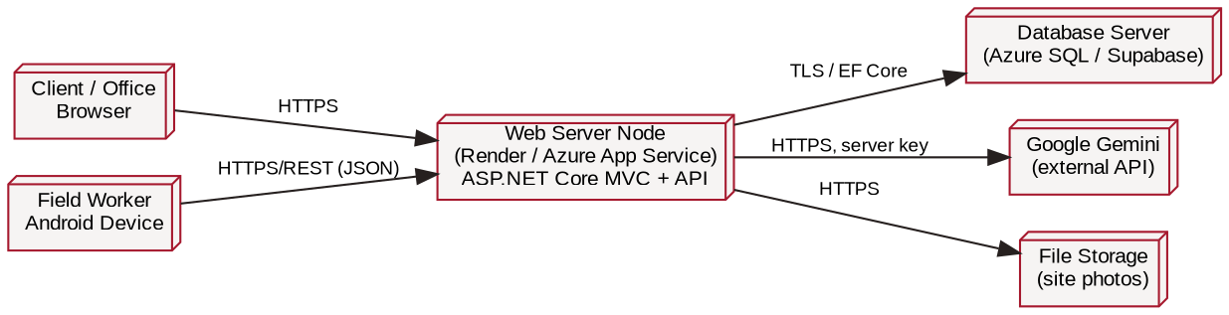
Figure 7 Deployment diagram
- Rollout strategy: deploy to a staging environment first, run smoke tests against the auth, quotation and AI endpoints, then promote to production via the CD pipeline described in Section 11.
- Rollback: the previous container image / build artifact is retained so a failed deployment can be reverted within minutes.
- Environment separation: development, staging and production each use separate database instances and separate API keys, configured through environment variables.

6. Data Schema

6.1 Choice of Technology
The system uses a relational database (SQL Server via Azure SQL, with EF Core as the ORM). This choice was made because the core data — clients, quotations, invoices, projects and users — has clearly defined relationships and benefits from enforced foreign-key integrity, ACID transactions (particularly important when a quotation approval must atomically create an invoice), and mature tooling for migrations. EF Core's Code-First migrations give the team a version-controlled history of schema changes, satisfying the requirement to track schema evolution rather than manually creating tables.
An alternative NoSQL option (e.g. Firebase Firestore) was considered for its low setup overhead, but was not chosen because the reporting and auditing requirements benefit more from SQL's join and aggregation capabilities, and because a strictly-typed relational schema reduces the risk of inconsistent data being written from two different client applications (web and mobile). As the platform scales, read-heavy reporting queries can be optimised with indexes on frequently filtered columns (ClientId, ProjectId, Status).

6.2 Entity Relationship Diagram
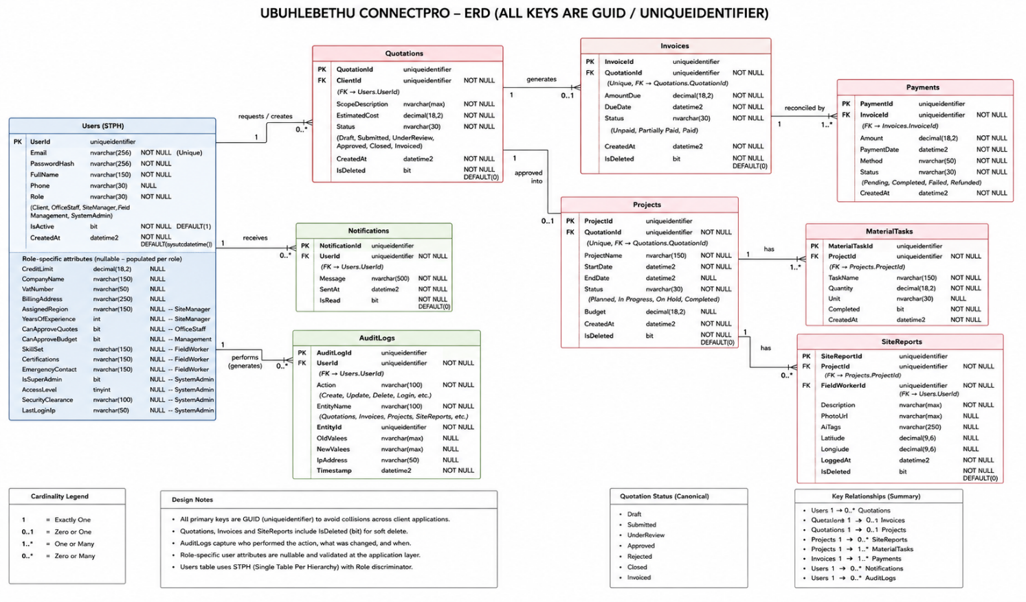
Figure 8 Entity Relationship Diagram
- Users to Quotations: One-to-many — a single User (specifically a Client) may initiate multiple Quotations, while each Quotation is associated with exactly one Client User.
- Quotations to Invoices: One-to-one (or zero-to-one) — each Quotation may generate at most one Invoice upon approval, and each Invoice corresponds to exactly one Quotation.
- Quotations to Projects: One-to-one (or zero-to-one) — an approved Quotation may result in at most one Project, and each Project is derived from exactly one Quotation.
- Projects to SiteReports: One-to-many — a single Project can have multiple SiteReports logged over its lifecycle, while each SiteReport belongs to exactly one Project.
- Projects to MaterialTasks: One-to-many — a single Project can contain multiple MaterialTasks tracking individual work items, and each MaterialTask is associated with exactly one Project.
- Users to Notifications: One-to-many — a single User may receive multiple Notifications, while each Notification is directed to exactly one User.
- Users to AuditLogs: One-to-many — a single User may generate multiple AuditLog entries through their actions, while each AuditLog record is attributed to exactly one User.

All primary keys use GUIDs to avoid collisions across the two client applications writing concurrently. Quotations, Invoices and SiteReports include an IsDeleted flag to support soft delete rather than permanent removal of records, and AuditLogs capture who performed create/update/delete actions on core records and when.
The domain model's six distinct role classes—Client, OfficeStaff, SiteManager, FieldWorker, Management, and SystemAdmin—are consolidated into a single Users table in the ERD with a Role discriminator column. This represents a deliberate single-table-per-hierarchy (STPH) inheritance mapping strategy, chosen because all role types share core authentication fields (UserId, Email, PasswordHash, Phone, IsActive, CreatedAt) and differ only in role-specific attributes that are sparsely populated across records. STPH simplifies authentication logic by allowing ASP.NET Core Identity to query a single table for credential verification, role claim retrieval, and RBAC permission checks, rather than performing costly joins or polymorphic unions across six separate tables. Role-specific attributes are accommodated through nullable columns—for example, CreditLimit applies only to Clients, SkillSet only to FieldWorkers, and CanApproveBudget only to Management—with application-layer validation ensuring that only permitted roles access or modify their designated fields. This approach also streamlines audit trail queries (since every user action logs a single numeric UserId) and simplifies reporting dashboards that aggregate user metrics across all roles without complex table unions. While STPH introduces some nullable columns and requires careful business-logic enforcement, these trade-offs are acceptable given the relatively low number of role-specific attributes per type and the substantial performance and maintainability benefits gained for authentication and authorization workflows, which are invoked on nearly every API request.

7. Architecture Artifacts

7.1 Design Patterns
Three design patterns are applied:
- Repository pattern — isolates data-access logic (e.g. IQuotationRepository) behind an interface, so the service layer is not coupled to EF Core directly, and unit tests can mock the repository.
- Factory Method — used to construct the correct AI-request payload depending on feature (quotation estimate, chatbot query, or search query translation), so new AI features can be added without changing the calling code.
- Observer pattern — used for the notification system: when a quotation's status changes, registered observers (email notifier, in-app notifier) are triggered without the quotation service needing to know about each notification channel directly.
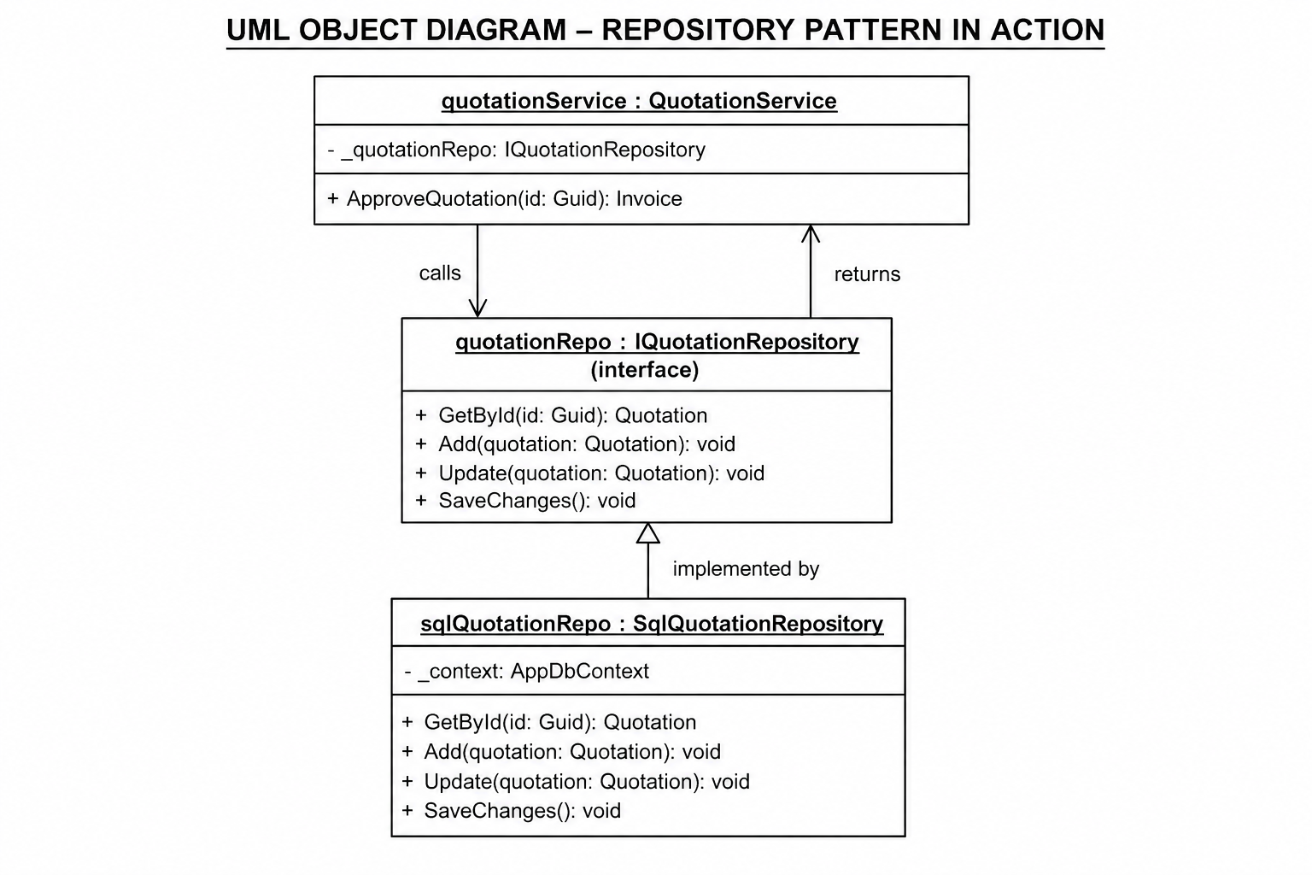
Figure 9 Repository pattern
This is Repository pattern applied to the quotation workflow. QuotationService depends on IQuotationRepository, not the concrete SqlQuotationRepository class. This allows unit tests to provide a mock repository without touching the database. At runtime, dependency injection supplies the SQL implementation. The same pattern is applied to Invoice, Project, and SiteReport entities

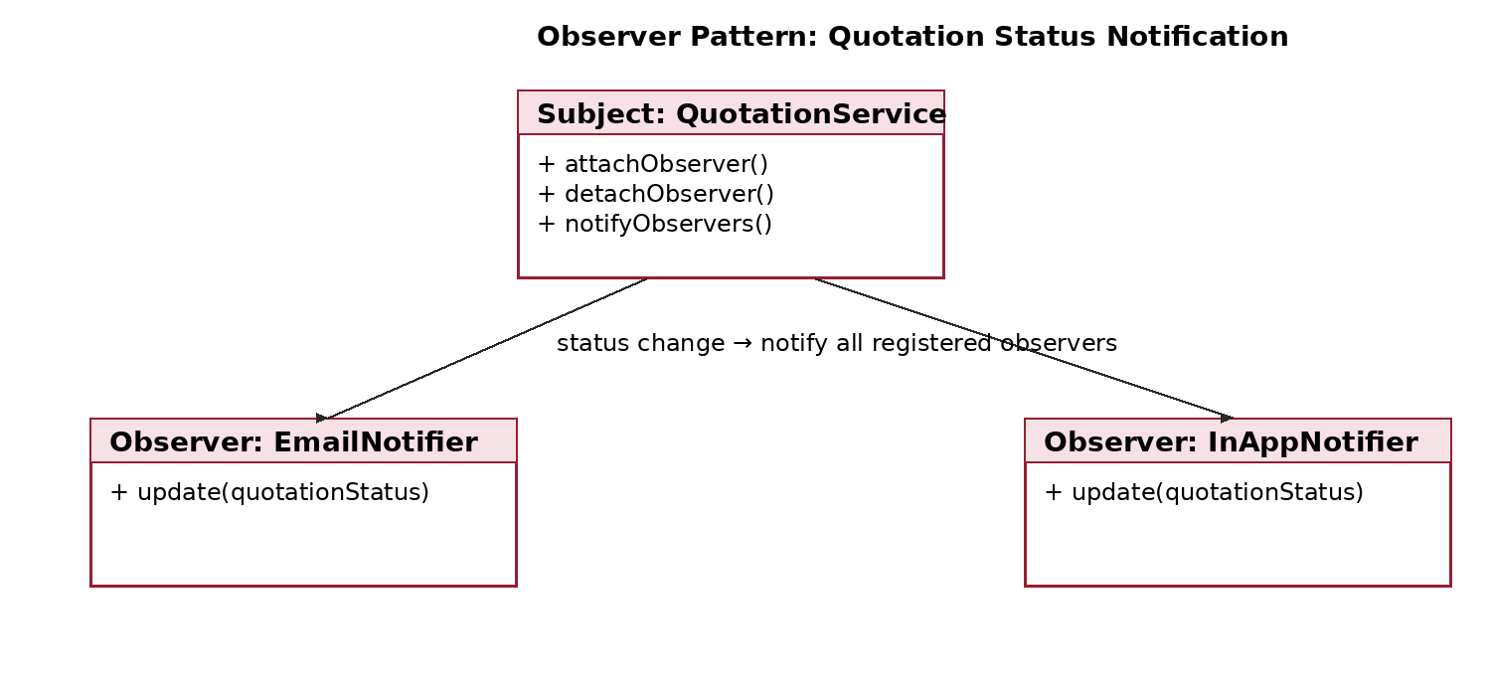
Figure 10 Observer pattern
The Observer pattern is applied when a quotation status changes. QuotationService acts as the subject and notifies registered observers such as EmailNotifier and InAppNotifier. This keeps notification channels independent from quotation business logic and allows additional notification mechanisms to be added without changing the quotation service.

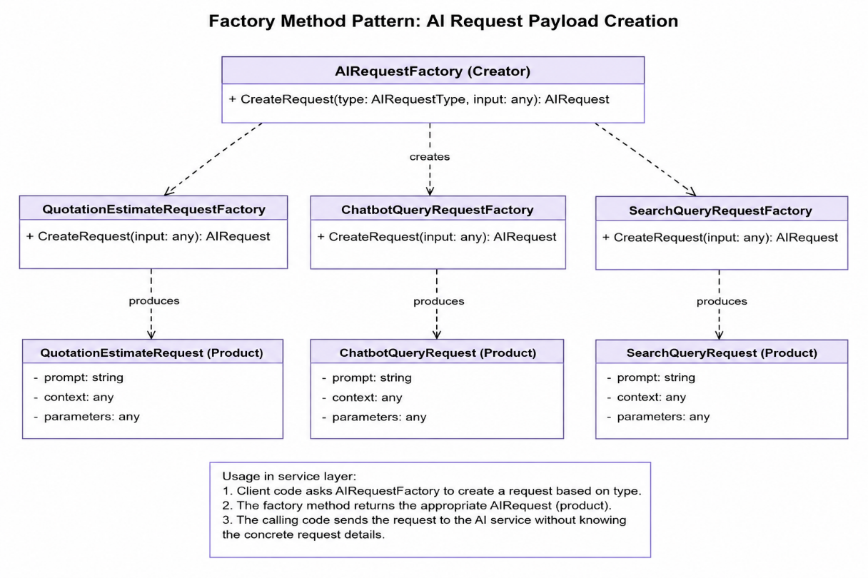
Figure 11 Factory Method pattern
The Factory Method pattern is used to create the appropriate AI request payload based on the feature being used. The AIRequestFactory determines whether the system needs a quotation estimate, chatbot query, or search query request, and the corresponding factory creates the correct request object. This keeps the calling code independent from the specific request implementations and makes it easier to add new AI features in the future without changing the existing service logic.

7.2 Architecture Patterns
The system follows a layered (N-tier) architecture combined with a REST API, keeping presentation, business logic and data layers separate. This was chosen over a monolithic MVC-only approach because it lets both the web application and the Kotlin mobile app consume the same backend through a single, documented API, rather than duplicating business logic in two places.
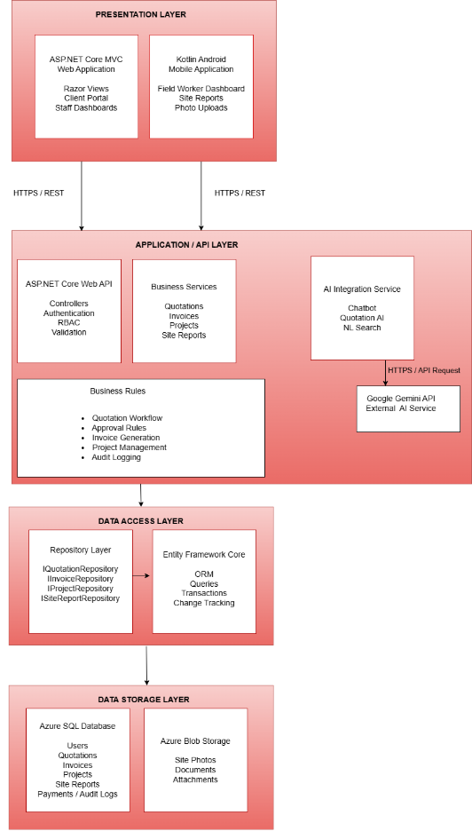
Figure 12: Layered architecture — presentation, business logic and data layers

7.3 Cloud Architecture
The web application, backend API and database are hosted on Azure, using Azure App Service for the API, Azure SQL Database for the relational data, and Azure Blob Storage for site photos. The API sits in an application subnet reachable from the internet over HTTPS (port 443), while the database sits in a private/managed network reachable only from the API over TLS-encrypted TCP (port 1433). The ASP.NET Core MVC web application and REST API are hosted on Azure App Service. The web application uses Razor Views for server-side page rendering, while the REST API provides a shared backend interface consumed by both the web application and Kotlin Android mobile application.

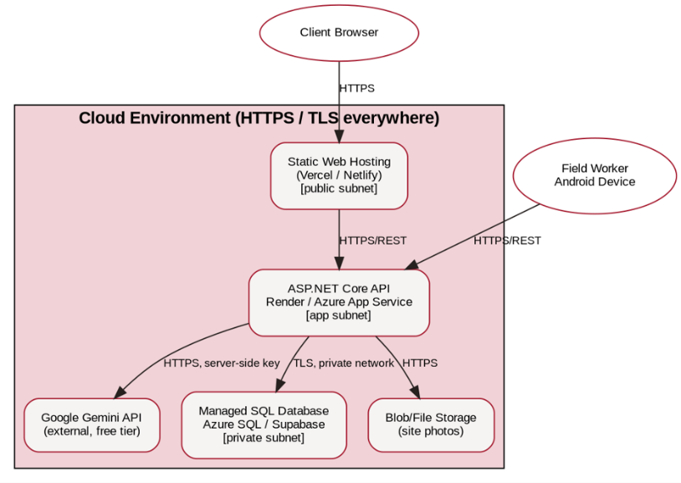
Figure 13 Cloud architecture and network segregation

8. Security
Security risk analysis complements the technical controls below. The following register identifies representative threats, their assessed likelihood and impact, and the corresponding mitigation strategy:
Threat / Risk | Likelihood | Impact | Mitigation Strategy
Man-in-the-Middle / Network Interception | Low | High | All client-to-server communication uses HTTPS/TLS. Database connections are encrypted using TLS, and insecure HTTP traffic is redirected or rejected where applicable.
Cross-Site Scripting (XSS) | Medium | High | Razor output encoding, server-side sanitisation and input validation. Rich-text content is sanitised before storage, and user input is never rendered as trusted HTML without validation.
SQL Injection | Low | High | EF Core parameterised queries are used throughout. Raw SQL containing string-concatenated user input is prohibited. Input validation is applied to API parameters.
Broken Access Control / IDOR | Medium | High | Server-side authorization checks verify ownership and role permissions for every protected resource. Record IDs alone never grant access.
Privilege Escalation | Low | High | RBAC is enforced server-side using role claims and authorization policies. Administrative functions are restricted to authorised roles, and client-side controls cannot bypass API authorization.
Stolen JWT / Refresh Token | Low | High | Short-lived access tokens, refresh-token rotation, secure Android Keystore storage and server-side token validation. Revocation is supported when a session or account is compromised.
Brute-Force / Credential-Stuffing Attacks | Medium | High | Login rate limiting, temporary account lockout, monitoring of repeated failed attempts and strong password requirements. Suspicious authentication activity is logged.
Cross-Site Request Forgery (CSRF) | Low | High | Anti-forgery tokens are applied to state-changing web forms. API authentication uses authorization headers for mobile requests, reducing classic cookie-based CSRF exposure.
Insecure File Uploads | Medium | High | Restrict permitted file types and sizes, validate MIME type and file signatures, generate safe filenames, store uploads outside executable application directories and scan or reject suspicious files.
Sensitive Data Exposure | Medium | High | API responses expose only fields required by the requesting role. Sensitive information is protected by authorization rules. Secrets and credentials are never written to logs. HTTPS/TLS protects data in transit.

Costing note: all figures are estimates in South African Rand (ZAR), based on indicative provider/free-tier pricing available at the time of Task 1 preparation (August 2026). Actual costs will depend on traffic, storage, AI usage, database capacity and provider pricing at deployment.

8.1 Authentication & Access Control
- Registration, login and logout are implemented by the team using ASP.NET Core Identity — not a third-party plugin.
- Passwords are hashed using Identity's built-in bcrypt-based hasher; plain-text passwords are never stored or logged.
- JWT access tokens are short-lived, with refresh tokens used to renew sessions; role claims embedded in the token are re-validated on every protected endpoint server-side.
- Role-based access control (RBAC) is enforced in the API layer using [Authorize(Roles=...)] attributes, so hiding a button on the front end is never the only protection.

8.2 Common Web Vulnerabilities
- Cross-Site Scripting (XSS): all user-supplied input (e.g. quotation scope text, chatbot messages) is output-encoded by Razor views by default, and rich text fields are sanitised server-side before storage.
- SQL Injection: EF Core's parameterised queries are used throughout; no raw string-concatenated SQL is used.
- Cross-Site Request Forgery (CSRF): anti-forgery tokens are used on all state-changing form submissions in the web application; the mobile app uses token-based auth headers, which are not vulnerable to classic CSRF.
- Brute-force protection: login attempts are rate-limited and accounts are temporarily locked after repeated failures.

8.3 Data & Infrastructure Security
- All traffic is served over HTTPS; the database connection uses TLS.
- Secrets (database connection string, JWT signing key, Gemini API key) are stored as environment variables, never committed to Git, with a .env.example file documenting required variable names.
- The AI service key is used only from the backend, so it is never exposed to the browser or the decompiled mobile APK.
- Sensitive fields (e.g. contact numbers) are only returned to users with the appropriate role.

9. DevOps
Rapid, reliable delivery is treated as a first-class requirement, not an afterthought. The team uses GitHub for version control with a simple Gitflow-style branching model: feature branches are created off develop, merged via Pull Request after at least one team member's review, and develop is periodically merged into main to trigger a release.

9.1 GitHub Actions Pipeline
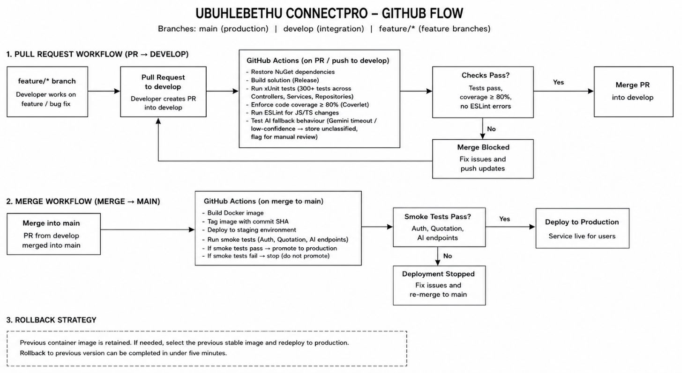
Figure 14 GitHub Actions branching and CI/CD workflow
On every Pull Request into develop, the GitHub Actions pipeline automatically restores NuGet dependencies, builds the solution in Release configuration, and runs the full xUnit test suite (covering 300+ tests across Controllers, Services, and Repositories) while enforcing a minimum code coverage of 80% via Coverlet; it also runs ESLint for any front-end JavaScript/TypeScript changes, blocking the merge if any test fails or coverage drops below the threshold. On every merge into main, a second workflow builds a Docker container image tagged with the commit SHA, deploys it to the staging environment, runs smoke tests against the auth, quotation, and AI endpoints, and promotes to production only if all smoke tests pass—while retaining the previous container image to enable instant rollback in under five minutes. As part of this pipeline, fallback behavior for AI features is built and tested: if a call to Gemini times out or returns a low-confidence result, the backend stores the request unclassified and flags it for manual review, ensuring that a slow or failed AI response never blocks core user actions like submitting a quotation or logging a site report.

10. Running Costs
The table below shows predicted monthly running costs at three scales, based on the free-tier allowances and published pricing of each provider at the time of writing. All figures are estimates and will be refined once real usage patterns are observed during Task 2.
Service | 100 users | 1,000 users | 10,000 users
Backend hosting (Render/Azure App Service) | Free tier | ≈ R350/mo | ≈ R1,400/mo
Database (Azure SQL / Supabase) | Free tier | ≈ R300/mo | ≈ R1,200/mo
File/blob storage (site photos) | Free tier | ≈ R80/mo | ≈ R450/mo
Google Gemini API (AI features) | Free tier | Free tier / ≈ R150/mo | ≈ R900/mo
Static web hosting (Vercel/Netlify) | Free tier | Free tier | ≈ R350/mo
Estimated total | R0/mo | ≈ R880/mo | ≈ R4,300/mo

10.1 Two-Year Growth Projection
Ubuhlebethu currently serves clients across five provinces with no digital system, so early adoption is expected to be gradual. The team projects roughly 100 active users (clients, office staff and field workers combined) within the first three months, growing to around 1,000 by the end of year one as more site teams and repeat clients are onboarded, and towards 5,000–10,000 by the end of year two if the system is rolled out company-wide and offered to a wider client base. Costs scale from free-tier (R0/month) at launch to an estimated R4,300/month at 10,000 users — a cost the company can offset against the reduced admin time and faster invoicing cycle the system is designed to deliver.
The adoption timeline (approximately 100 active users in the first three months, around 1,000 by the end of year one, and 5,000–10,000 by the end of year two) is a planning assumption informed by the client discussion held on 05 August 2026 and should be validated with management during Task 2. Where the client has not supplied a specific adoption figure, the team treats the value as an estimate rather than a confirmed commitment.

11. Change Management
Ubuhlebethu currently has no digital system in this space, so adoption is primarily about building a new habit rather than migrating data from a legacy platform.

11.1 Organizational Adoption
The organisation is expected to adopt ConnectPro because it directly reduces the QS costing time, removes the risk of quotations being lost in email/WhatsApp threads, and gives management visibility they currently do not have. Management buy-in will be secured by demonstrating the system live (as in the Task 2 implementation presentation) with real, department-relevant data before full rollout.

11.2 User Adoption
Office/QS staff and site managers will be onboarded first, since they are the smallest and most process-driven user group, followed by field workers, and finally opened up to clients. Short, role-specific training sessions (roughly 30 minutes each) will be run for each group, supported by the user guide produced in Task 3.
Training will be delivered by the development team during the initial rollout, using short live demonstrations supported by the Task 3 user guide. Sessions will be role-specific and can be repeated for new staff; an identified Ubuhlebethu staff member can later act as an internal point of contact for routine onboarding.

11.3 Handover & Transition Plan
- Weeks 1–2 post-handover: parallel run — office staff continue logging quotations in their existing spreadsheet alongside the new system, to catch discrepancies before fully switching over.
- Weeks 3–4: full cut-over for office/QS and site managers; spreadsheets are archived, not deleted, for reference.
- Month 2: field workers onboarded with the mobile app; site managers spot-check early site reports for quality.
- Month 3 onward: client-facing portal opened to existing clients first, then included in new-client onboarding.
- Support: the development team remains available for a defined support window after handover to fix defects raised during real use, before formal handover of maintenance responsibility to Ubuhlebethu's IT contact.

12. Appendices

12.1 Declaration of Authenticity


Declaration of authenticity

I, ___Tshudufhadzo __Themba ___ID Number, ____0006285858087____ , hereby declare that this portfolio, and any evidence included therein, contains my own independent work and that I have not received help from other groups.

I confirm that we have not committed plagiarism in the accomplishment of this work, nor have I falsified and/or invented experimental data.

I accept the academic penalties that may be imposed for violations of the above.

STUDENT NUMBER: _ST10461617_______________________
STUDENT NAME: ___________Tshudufhadzo________________
STUDENT SIGNATURE: __________T.Themba___________ DATE: _17/08/2026__

12.2 Prototype Link
https://github.com/EMGPRS/insy7315-2026-task-1-thembatshudufhadzo.git

